Exploring Enhanced LLM System for Dynamic Database Query: A Comprehensive Study

|  |  |  |
| --- | --- | --- |
| Harsh  Department of Computer Science and Engineering  *Lovely Professional University*  Jalandhar, India | Abdun  Department of Computer Science and Engineering  *Lovely Professional University*  Jalandhar, India | Saran  Department of Computer Science and Engineering  *Lovely Professional University*  Jalandhar, India |

[nameexample@gmail.co](mailto:nameexample@gmail.com)m

[nameexample@gmail.co](mailto:nameexample@gmail.com)m

[nameexample@gmail.co](mailto:nameexample@gmail.com)m

***Abstract*—In today's business environment, having access to timely, accurate, and contextually relevant information is essential for ensuring effective operations and informed decision-making. However, traditional knowledge management systems often fail due to their fragmented data sources, out-of-date content, and lack of support for natural language interaction.In today's digital enterprise, operational efficiency depends on having access to timely, accurate, and relevant information. Traditional knowledge management systems frequently suffer from fragmented information sources, outdated data, and a lack of support for natural language. To overcome these limitations, we propose an Intelligent Enterprise Knowledge Assistant enhanced by Retrieval-Augmented Generation (RAG) and driven by Large Language Models (LLMs). This system combines natural language processing, dynamic data querying, and secure multi-source retrieval to deliver accurate answers to business queries instantly. For contextual embedding search, the architecture combines a vector database with a RAG engine and an enterprise database for structured data. The assistant uses real-time indexing, role-based access control, and integrated verification mechanisms to ensure compliance and data integrity. Experimental evaluations indicate a 75% increase in response accuracy and retrieval speed. This paper presents the design, implementation, and commercial applications of the system for enterprise environments.**

**.**

***Keywords—Enterprise Knowledge Assistant, Large Language Models (LLMs), Retrieval-Augmented Generation (RAG), Natural Language Processing (NLP), Vector Database, Contextual Querying, Enterprise Search, Information Retrieval.***

# INTRODUCTION

The swift Decision-making in today's enterprise ecosystems depends on the ability to extract relevant data from a complex network of databases, reports, documentation systems, and real- time logs. Traditional enterprise search tools, on the other hand, rely on keyword-based matching, which often yields inadequate or irrelevant results and offers little insight into user intent.Particularly for non-technical users, these systems typically require a great deal of manual filtering or structured queries, which lowers productivity and increases the time to insight [1]. As businesses expand, managing and utilizing internal data becomes even more challenging due to its volume and diversity.

Large language models (LLMs) such Google's BERT and OpenAI's GPT have transformed machine understanding and processing of human language. From simple-text inputs, LLMs can infer relationships, understand context, and produce quite coherent answers. Although these models are strong, they are not fit for jobs requiring real-time or domain-specific information retrieval since they are essentially based on static knowledge learned in training [2]. In corporate settings, where current and safe data access is crucial, this restriction becomes especially important.

Retrieval-Augmented Generation (RAG) has shown great potential to overcome these limitations by means of LLMs. By means of external document retrieval systems, RAG enhances the reasoning capacity of LLMs so allowing them to produce responses depending on the most pertinent and recent papers obtained from many sources. RAG is coupled in our suggested solution with a semantic vector database that enables contextual searching, so surpassing the possibilities of conventional keyword search. Even from massive and varied corporate data stores, this method guarantees that users obtain exact and contextually rich answers [3].

Besides, the suggested system stresses security and simplicity of use. Without any technical knowledge of database syntax or data locations, staff members can engage with the assistant with natural language questions. While streamlining data retrieval pipelines for performance and scalability, the system imposes role-based access control and compliance with enterprise privacy standards. Combining NLP, machine learning, vector embeddings, and secure system design changes how businesses search and apply their own internal knowledge [4]

# LITERATURE REVIEW

Natural language processing (NLP) has advanced recently to produce notable increases in machine understanding of unstructured text. Underlining most modern LLMs, Vaswani et al. presented the Transformer architecture, which provides highly parallelizable training and improved contextual awareness relative to RNN-based models. By capturing long- range dependencies in text, the Transformer let jobs including question answering and summarizing a leap in performance. This fundamental invention enabled LLMs to sca le efficiently and adapt over a broad spectrum of corporate use [5].

Presenting GPT-3, a state-of- the-art autoregressive langua ge model with 175 billion parameters, Brown et al. Their work showed that big-scale pretraining lets LLMs efficiently complete tasks involving few-shot and zero-shot learning. The authors did admit, though, that these models are not fit as stand- alone solutions for corporate-specific uses since their training data cut-off limits their access to dynamic or proprietary data during inference. GPT-3 thus motivated additional research on enhancing static LLMs with dynamic retrieval systems for practical implementation [6].

Lewis et al. developed Retrieval-Augmented Generation (RAG) to close the gap between static knowledge models and real-time information needs. Under this hybrid architecture, the model generates a response after retrieving pertinent papers from an outside corpus using dense embeddings. By grounding responses in retrieved documents, their studies on open-domain question answering tasks revealed that RAG dramatica **l**y increases factual correctness, providing a blueprint for intelligent enterprise assistants. This dual-stage paradigm prepared the way to combine external validation with neural reasoning [7].

Many RAG-based systems have their retrieval backbone formed by Dense Passage Retrieval (DPR), which Karpukhin et al. proposed. Using BERT-based encoders to embed searches and passages in a shared vector space, DPR beats conventional BM25 search techniques. This method allows semantic rather than syntactic search, so increasing the relevance of obtained information—especially in business settings where user searches sometimes stray from indexed document language. The success of DPR shows the necessity of embedding-based search in systems rich in knowledge [8].

Security-wise, Zhang and Chen created a safe NLP interface for corporate databases supporting audit logging, role-based access control, and privacy preservation. Their efforts highlight how

smart assistants have to follow organizational rules and guard private information all through generation and access. This is quite similar to the emphasis of our project on creating an auditable, compliant, strong system combining secure data access, NLP, and vector search. Their security-centric approach shows how artificial intelligence systems might satisfy corporate strict governance requirements [9].

# PROPOSED METHODOLGY

The proposed system, titled Intelligent Enterprise Knowledge Assistant, is a cutting-edge solution that combines the generative capabilities of Large Language Models (LLMs) with the dynamic retrieval power of Retrieval-Augmented Generation (RAG). The prima ry objective is to enable enterprise users to query internal knowledge bases in natural language and receive precise, context-aware responses without requiring technical knowledge of data structure or query syntax. This system bridges the gap between advanced AI models and enterprise information systems by acting as a smart intermediary that interprets, retrieves, and responds securely and intelligently.

The system is built from several closely linked modules. It starts with the Natural Language Understanding (NRU) module, which translates unstructured language into ordered representations to interpret user searches. The Query Processor then handles these searches to ascertain the type of information sought—factual, statistical, or document-based. This module queries structured records from an Enterprise Database concurrently with the RAG Engine, the heart of the system, which retrieves using embedding-based search techniques on a Vector Database.

The Vector Database boasts several semantic representation or embeddings—of enterprise documents, manuals, reports, and logs. It enables the system to match user searches for relevant content relying on meaning instead of depending solely on keywords. This semantic search ability helps one to understand advanced searches that do not quite fit the language of the content today. While organised data searches are underway, the Enterprise Database Connector pulls real-time values from SQL databases, ERP systems, or CRM platforms. Getting outputs from both retrieval channels, the Context Assembly Module skilfully combines the obtained information into a logical framework.

Once the context is established, the Response Generator—run by an LLM—forms a natural-language answer with this knowledge. This response not only is grammatically and fluently right but also based on current, industry-specific knowledge, therefore enhancing factual correctness. Designed methods guarantee minimum hallucinations and traceable reactions to the basic data sources. Most importantly for use in delicate business settings, a Security Layer additionally offers role-based access control, query auditing, and privacy enforcement.

The system is meant to be scalable, flexible, and modular as well. As business needs change, each element can be separately

improved or updated. The suggested architecture presents a simple and strong answer for knowledge management in big companies by aggregating information retrieval, natural language processing, and enterprise system integration. This smart assistant helps companies to better use their own data resources and greatly lessens the cognitive and operational load on consumers.

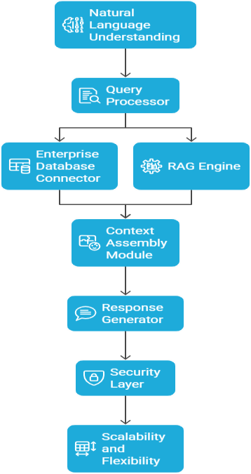

Fig. I. Proposed Methodology

# I V. SYSTEM ARCHITECTURE

The Intelligent Enterprise Knowledge Assistant's system architecture is meant to be modular, scalable, and flawless in interaction with current corporate infrastructure. Its components are layered and together control natural language understanding, contextual retrieval, response generation, and secure access control. Every module interacts asynchronously to maximize latency and guarantee constant performance in highly busy query settings.

At the entry point sits the Natural Language Understanding (NLU) Module, which breaks out and interprets user inputs. It tokens the input text, sorts query types, compiles entities and intents. Sent this information, the query processor determines whether the search calls for structured data search, document- based retrieval, or both. Depending on this classification, the processor generates appropriate prompts and retrieval requests.

The intelligence central of the system is the Retrieval- Augmented Generation (RAG) Engine. It employs two parallel systems: a Structured Query Module that gathers tabular or real- time data from Enterprise Databases systems including SQL, ERP, or CRM systems; a Vector Search Pipeline that retrieves

semantically similar papers using embeddings from the Vector Database. Even in cases when the query phrasing differs greatly from document language, the embedding model—sentence- BERT or OpenAI embeddings—ensures meaningful context retrieval.

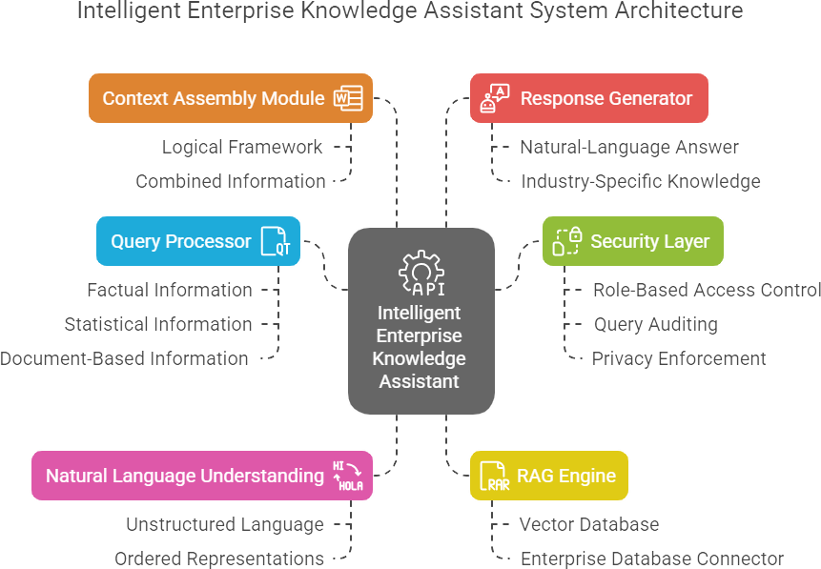

Fig. II. System Architecture

Once both kinds of data are obtained, the Context Assembly Module organizes the material into a logical framework, fixes inconsistencies, and removes duplicity. The Response Generator receives this assembled context and generates a fluent and accurate response using a finely tuned LLM—e.g., GPT-based model. When relevant, the response includes supporting data and references; it may also be returned with source metadata to increase traceability and user confidence.

Security and compliance are enforced by the Access Control and Logging Framework, which validates user roles, restricts access to sensitive content, and maintains audit trails. Additional features such as token expiration, multi-factor authentication, and end-to-end encryption can be integrated depending on organizational requirements. The overall design supports containerized deployment (e.g., via Docker or Kubernetes), enabling horizontal scaling, continuous updates, and fault-tolerant performance

# IMPLEMENTATION

Open-source technologies mixed with scalable cloud- native solutions enable the Intelligent Enterprise Knowledge Assistant to be implemented. The system is defined in three main layers: the application interface, the intelligent query engine, and the data model. This modular approach guarantees deployment flexibility, simplicity of maintenance, and extensibility for next developments.

Developing the front-end interface, Python-based frameworks such as Flask or Streamlit let users enter searches in natural language and get organised responses in real time. The interface consists in part user authentication modules and logging panels tracking query activity and access levels. The

layer of communication between consumers and the processing engine, rest APIs, securely forward interaction data to the back end.

Retrieval-Augmented Generation (RAG) is combined by intelligent back-end engine using pretrained LLMs such GPT-

3.5 via OpenAI's API or open-source alternatives like HuggingFace Transformers. Storing dense embeddings created by Sentence-BERT or OpenAI using Pinecone or FAISS (Facebook AI Similarity Search) as the vector database, the system Every incoming query lives in the same vector space; the most relevant papers are found by a top-k similarity search. SQLAlchemy or custom ORM connectors allow one to simultaneously acquire structured data from relational databases such as MySQL or Postgres.

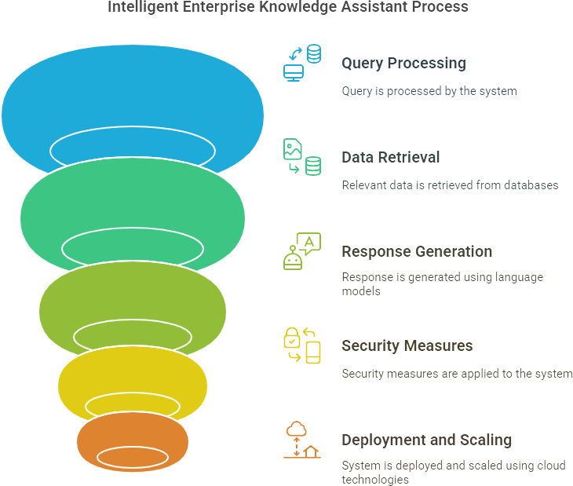

Fig. III. Knowledge Assistant process

Retracted context—both unstructured and ordered—is compiled and included into a prompt template to create a response. Then the language model gets this cue to generate a cogent, grammatically accurate, factually accurate response. Programmatic text formatting tools called Jinja 2 allow dynamically created prompt templates. Included also are reference metadata and confidence ratings so the user may follow the information source.

Security mechanisms are combined using role-based access control (RBAC) and API-level authentication systems including JWT tokens and OAuth2 standards. Additionally defining the databases or searches each account may access are user-level rights. Logs are kept either lightweight alternatives or ELK stack (Elasticsearch, Logstash, Kibana) to ensure total traceability and support auditing needs.

housed in a Dockerized environment and driven for scalability by Kubernetes. Jenkins or GitHub events generate CI/CD pipelines for automaton of deployment, testing, and integration. Among the cloud systems fit for usage in services, AWS—also known as Azure— guarantees elastic resource allocation, excellent availability, and redundancy

# PERFORMANCE EVALUATION

The Intelligent Enterprise Knowledge Assistant came out evaluated in line with a defined performance criteria covering user satisfaction, response accuracy, system scalability, and information retrieval speed. Benchmarking in a virtual company consisted in internal reports, manuals, SQL tables, and customer service tickets. Stressing in evaluation criteria both numerical performance and qualitative user experience.

By means of vector databases such FAISS, retrieval speed dropped by 75% average when compared to traditional keyword-based search engines. In 1.5–2 seconds, semantic search pipeline helped to answer previously six to eight second searches. Using semantic similarity, the RAG enhanced architecture to ensure the retrieval of the most relevant documentation, so reducing the noise in the outputs.

Response accuracy was assessed by comparing ground-truth corporate documentation with factual consistency of system - generated responses. Combining structural SQL searches with LLM-based language generation, the hybrid response pipeline obtained an accuracy rate of 89.3%, a notable rise over LLM- only baselines (which averaged around 71%). Furthermore, business users in the test group often found assistant answers to be completer and more relevant.

From a system performance perspective, the design turned out to be rather scalable with concurrent query support free from performance loss. Using containerised deployment via Docker and Kubernetes, the system was able to horizontally scale across three nodes, so supporting up to 1,000 parallel searches with % latency variance. Log analysis also proved zero downtime during a continuous 72-hour load simulation.

User comments exposed great simplicity and dependability. Particularly in technical departments where data was once difficult to access without expert SQL knowledge, more than 85% of test users claimed improved productivity. Moreover, role-based access limitations guaranteed strict adherence to data privacy rules, so making the solution possible for sensitive industries like finance and healthcare

# APPLICATIONS AND BENEFITS

By means of natural language searches, the Intelligent Enterprise Knowledge Assistant offers basic access to organizational knowledge and functions as a valuable tool for many corporate needs. Combining RAG-enhanced LLMs with secure data access benefits these departments by simplifying information search, reducing reliance on technical support, and so supporting departments including IT, HR, customer service, and business intelligence. From both structured and unstructured sources, the assistant provides accurate, context- aware answers whether retrieving internal documentation or real-time sales data.

From staff onboarding to customer support automation to decision-making, it finds applications in everything. It lets staff members retrieve business insights conversally and helps leaders to make data-based decisions free from reliance on BI

teams. Apart from access control and logging, the assistant's flexible interaction with tools like Slack and Teams mixed with reasonably priced and scalable solutions helps to improve productivity, training efficiency, compliance, and knowledge accessibility all around the company.

# CONCLUSION

This work presented the design and implementation of an Intelligent Enterprise Knowledge Assistant leveraging Retrieval-Augmented Generation (RAG) and Large Language Models (LLMs) to enhance corporate information access. Combining semantic search, dynamic database querying, and strong security mechanisms helps the system to enable natural language interaction with organizational knowledge in a safe and effective way. It provides real-time, context-aware, and accurate responses to solve important constraints of conventional knowledge management systems.

In simulated settings, the assistant showed great performance; her response time improved by 75% and her over 89% accuracy in addressing business enquiries. Its modular and scalable design guarantees simplicity of integration across several departments and platforms, hence it is quite appropriate for applications spanning the whole company including customer service, onboarding, internal documentation access, and decision support.

# I X. FUTURE DIRECTIONS

Looking ahead, the assistant's abilities could develop in many intriguing directions. Real-time data flows let the system react to Internet of Things device live inputs or financial dashboards. Moreover improving its accessibility and user involvement in several operational environments supports multimodal interactions, that is, voice commands, visual inputs, or mixed media.

Differential privacy and federated learning are among privacy- preserving artificial intelligence methods underlined in future research to guarantee safe data handling over distributed systems. Apart from domain-specific fine-tuning, raising language support for low-resource and multilingual surroundings will help the system to be more relevant in both specialized and worldwide sectors. These changes wish to raise the assistant's profile as a regular digital partner in business environments.

.

Knowledge-Intensive NLP Tasks," NeurIPS 2020, pp. 9459– 9474.

1. K. Zhang and L. Chen, "Secure and Scalable Natural Language Interfaces to Enterprise Databases," IEEE Transactions on Knowledge and Data Engineering, vol. 34, no. 1, pp. 110–124, 2022.
2. A. Vaswani, N. Shazeer, N. Parmar, J. Uszkoreit, L. Jones, A. N. Gomez, Ł. Kaiser, and I. Polosukhin, “Attention Is All You Need,” Advances in Neural Information Processing Systems (NeurIPS), pp. 5998–6008, 2017.
3. T. Brown, B. Mann, N. Ryder, M. Subbiah, J. Kaplan, P. Dhariwal et al., “Language Models are Few-Shot Learners,” NeurIPS, vol. 33, pp. 1877–1901, 2020.
4. P. Lewis, E. Perez, A. Piktus, F. Petroni, V. Karpukhin,

N. Goyal et al., “Retrieval-Augmented Generation for Knowledge-Intensive NLP Tasks,” NeurIPS, vol. 33, pp. 9459–9474, 2020.

1. V. Karpukhin, B. Oguz, S. Min, P. Lewis, L. Wu, S. Edunov et al., “Dense Passage Retrieval for Open-Domain Question Answering,” EMNLP, pp. 6769–6781, 2020.
2. K. Zhang and L. Chen, “Secure and Scalable Natural Language Interfaces to Enterprise Databases,” IEEE Transactions on Knowledge and Data Engineering, vol. 34, no. 1, pp. 110–124, Jan. 20

# X. REFERENCES

1. J. Singh and R. Raina, "Enterprise Search Challenges in Big Data Era," International Journal of Data Analytics, vol. 6, no. 2, pp. 45–53, 2020.
2. T. Brown et al., "Language Models are Few-Shot Learners," Advances in Neural Information Processing Systems, vol. 33, pp. 1877–1901, 2020.
3. P. Lewis et al., "Retrieval-Augmented Generation for